Gravitation and Equilibrium Test

Aranmore Test 2 2009

USED
3. The Hubble Space Telescope (of mass 1.16 x 10⁴ kg) orbits the earth in a circular orbit 6.10 x 10² km above the
surface of the earth.

(a) Calculate the gravitational force of attraction between the earth and the telescope.

(2 marks)

(b) Calculate the period (T) of the Space Telescope about Earth.

(3 marks)
USED
4. Given that the period of orbit of the moon is 27.3 days, determine the period of the international space station,
which has a mass of 7.50 tonne, given that the radius of its orbit is of the earth-moon radius.

(4 marks)
Aranmore test 3 2009

1. Explain (with the aid of diagrams) why a person carrying a backpack or suitcase must adjust their balance when
carrying a heavy load.

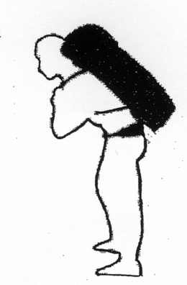

(4 marks)
USED
2. People with severe arthritis in their hands often have difficulty turning taps on and off. A tap-making company
has recognised this and developed a device that fits over the tap and has two arms as shown in the diagram
below. Explain the principle upon which this works.

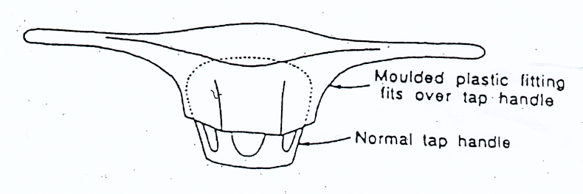

(4 marks)

3. Calculate the force exerted by a biceps muscle when lifting a 3.00 kg mass. Assume the biceps muscle is
attached 40.0 mm from the elbow joint and acts at right angles to the bone. The lower arm has a mass of 1.70 kg
and is considered uniform.

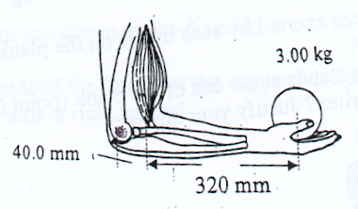

(4 marks)
USED
1. An 85.0 kg painter is standing on a plank, which rests on two trestles, while painting the upper section of a wall.
Assume that the plank is uniform and has a mass of 15.0 kg.

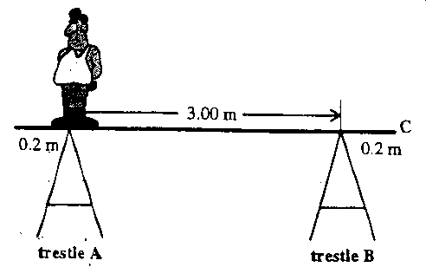

(a) Calculate the forces exerted by each trestle on the plank if the painter stands at trestle A.

(5 marks)

(b) If the painter stands at the end of the plank (i.e. point C),will the system remain in equilibrium? Use a
calculation to justify your answer.

(3 mark)
USED
2. You are designing a pot plant shelf that can hang from a single point. The shelf has a mass of 3.50 kg and is
1.40 m in length and you allow for three plants with masses no more than 2.50 kg each.

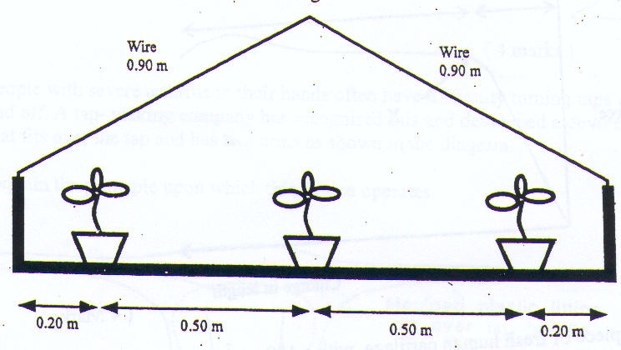

You need to determine the gauge (diameter) of the 0.900 m cables required to support the shelf.

(a) Determine the tension in each of the cables.

(4 marks)
USED
3. The diagram below shows how a set of traffic lights can be suspended from a building at the side of a road.
Copper wire holds the 5.00 m long uniform rigid pole in place. The wire is attached to the wall at bracket A and
the pole is attached to the wall at bracket B. The pole weighs 54.0 N and the traffic lights weigh 2.00 x 10² N.
Other dimensions are shown in the diagram.

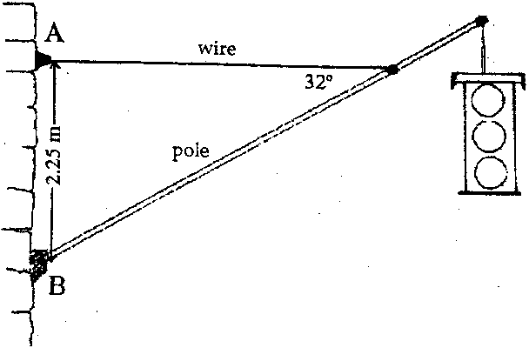

(a) Are brackets A and B under tension or compression?

Bracket A: Bracket B:

(1 mark)

(b) Find the magnitude of the tension force that the wire exerts on the pole.

(4 marks)

Aranmore Test 2 2008
USED
5. Deimos is a small moon that orbits Mars. It has a mass of 1.80 x 10¹⁵ kg and orbits at a mean distance of
2.64 x 10⁷ m fom the centre of the planet. Its period of orbit is 43.1 hours.

(a) Use this information to determine the mass of teh planet Mars.

(4)

(b) The Mars Survey Orbiter was placed in a stable orbit above Mars during a NASA mission. It was given a
period of revolution of 95.0 minutes. Given the radius of Mars is 3.39 x 10⁶ m, determine the height of
the Orbiter above the surface of the planet.

(4)

(c) What would be the acceleration due to gravity on the surface of Mars?

(3)
USED
5. A long-handled shovel 1.80 m long is leaning against a smooth wall in the Maintenance Shed. It has a mass of 3.50 kg and its centre of mass is 60.0 cm from the bottom. Assuming the handle and shovel forms a straight line. Calculate the reaction force exerted by the wall if the handle is 25.0 ° to the wall.
(4 marks)
25.0°

